

**Ispit iz predmeta IT350 – Baze podataka**

**03.11.2019.**

*Ispit traje 180 minuta*

|  |  |  |  |  |  |
| --- | --- | --- | --- | --- | --- |
| *Ime i prezime* | *Broj indeksa* | *Zadatak 1* | *Zadatak 2* | *Zadatak 3* | *Ukupno* |
|  |  |  |  |  |  |

***Napomene:***

1. Da bi se ispit položio, neophodno je osvojiti minimalno ***10 poena*** na zadacima i minimalno ***5 poena*** na teorijskim pitanjima.
2. Za vreme ispita nije dozvoljeno korišćenje mobilnih telefona ili drugih komunikacionih uređaja, kao ni Interneta.
3. Za izradu konceptualnog modela koristiti *PowerDesigner*.
4. DDL naredbe iz zadatka 1 i upite iz zadatka 2 sačuvati kao .sql fajl.
5. Sve fajlove imenujete na sledeći način: IT350-Novembar-2019-BrInd-ImePrezime-RedniBrojZadatka. Npr. *IT350-Novembar-2019-1234-VeljkoGrkovic-Zad1a*Fajlove smeštate u folder sa nazivom ***IT350-Novembar-2019-BrInd-ImePrezime***, a pre predaje radova folder arhivirati. **Nepravilno imenovani radovi neće biti ocenjivani.**
6. Po završetku, javite se dežurnom profesoru/asistentu koji će od vas preuzeti vaš rad.   
   **Slanje radova mail-om nije dozvoljeno.**

***Zadaci i pitanja:***

1. **Pitanja (10 poena):** Odgovoriti na sledeća pitanja.
   1. **(3 poena)** Tabelu koja je predstavljena na slici 1., normalizovati i normalizovan oblik tabele predstaviti u obliku E/R dijagrama

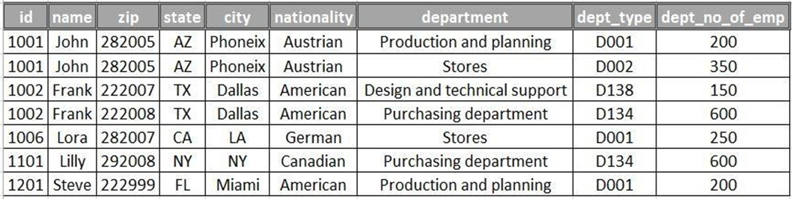

Slika 1- Zaposleni tabela

* 1. **(2 poena)** Kako se koristi *After image*, a kako *Before image* pri opravku baza podataka?
  2. **(2 poena)** Šta se rešava objektno-relacionim mapiranjem?
  3. **(3 poena)** Na osnovu date relacione baze podataka (slika 2) kreirati JSON dokument.  
     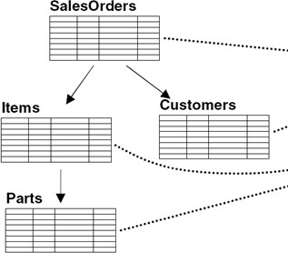

Slika 2 Relaciona BP Prodaja

1. **Zadatak (10 poena):** Baza podataka za firmu FutureFurniture.

*FutureFurniture* je firma koja se bavi proizvodnjom i prodajom nameštaja. Nameštaj ove firme možemo klasifikovati u sledeće kategorije: stolice, fotelje, tabureti, klupski stolovi i stolovi.

Nameštaj se prodaje u više prodavnica, a svaka od prodavnica ima više fiskalnih kasa. Na jednoj kasi uvek radi jedan od prodavaca. O prodavcima pamtimo ime, prezime, adresu, broj telefona, email, kao i radno mesto (prodavac, šef smene, menadžer prodavnice, …). Prodavci imaju dve smene u kojima rade, a za svakog od njih, za svaki radni dan, potrebno je znati u kojoj smeni rade, na kojoj kasi, kao i u kojoj od prodavnica rade.

Takođe, potrebno je voditi i evidenciju o kupcima. Svaki kupac ima ime, prezime, adresu, broj telefona i email. Potrebno je znati kada je koji kupac (kog datuma) kupio određeni komad nameštaja i kod kog prodavca. U jednoj kupovini kupac može da kupi više proizvoda za šta mu se izdaje jedinstveni račun.

2.1. Nacrtati konceptualni model ove baze podataka

2.2. Transformišite konceptualni model u fizički model

2.3. Od fizičkog modela generišite skripte za kreiranje tabela u MySQL bazi

1. **Zadatak (10 poena):** Na osnovu fizičkog modela baze podataka (model avio-kompanije), datog na slici 2., generisane su skripte za kreiranje baze podataka i unos test podataka. Izvršite priložene skripte i nad generisanom bazom izvršite sledeće:  
   1. *(1.5 poen)* Naći nazive svih tipova aviona, kao i ukupan broj aviona koje koristi avio-kompanija, koristeći LEFT JOIN. Rezultate urediti opadajući po broju aviona.  
        
      [SELECT](http://localhost/phpmyadmin/url.php?url=https://dev.mysql.com/doc/refman/5.5/en/select.html) `aircrafttype`.`AircraftTypeID`,`aircrafttype`.`AircraftName`, [COUNT](http://localhost/phpmyadmin/url.php?url=https://dev.mysql.com/doc/refman/5.5/en/group-by-functions.html#function_count)(`AIRCRAFT`.`AircraftTypeID`) AS `broj_aviona_koje_kompanija_koristi` FROM `aircrafttype` [LEFT](http://localhost/phpmyadmin/url.php?url=https://dev.mysql.com/doc/refman/5.5/en/string-functions.html#function_left) JOIN `Aircraft` ON AIRCRAFT.AircraftTypeID = aircrafttype.AircraftTypeID GROUP BY aircrafttype.AircraftTypeID ORDER BY `broj_aviona_koje_kompanija_koristi` DESC;
   2. *(1.5 poen)* Prikazati razliku broja letova koji saobraćaju na najdužoj i najkraćoj ruti.  
        
      najduza ruta:  
      [SELECT](http://localhost/phpmyadmin/url.php?url=https://dev.mysql.com/doc/refman/5.5/en/select.html) `ROUTEID`, `FROMAIRPORT`, ToAirport, [MAX](http://localhost/phpmyadmin/url.php?url=https://dev.mysql.com/doc/refman/5.5/en/group-by-functions.html#function_max)(`Distance`) AS DISTANCE FROM `route`  
        
      najkraca ruta:  
      [SELECT](http://localhost/phpmyadmin/url.php?url=https://dev.mysql.com/doc/refman/5.5/en/select.html) `ROUTEID`, `FROMAIRPORT`, ToAirport, [MIN](http://localhost/phpmyadmin/url.php?url=https://dev.mysql.com/doc/refman/5.5/en/group-by-functions.html#function_min)(`Distance`) AS DISTANCE FROM `route`

Brojih onih koji saobracaju na najduzoj ruti:

[SELECT](http://localhost/phpmyadmin/url.php?url=https://dev.mysql.com/doc/refman/5.5/en/select.html) [COUNT](http://localhost/phpmyadmin/url.php?url=https://dev.mysql.com/doc/refman/5.5/en/group-by-functions.html#function_count)(`Distance`) FROM `ROUTE` WHERE `Distance` = ([SELECT](http://localhost/phpmyadmin/url.php?url=https://dev.mysql.com/doc/refman/5.5/en/select.html) [MAX](http://localhost/phpmyadmin/url.php?url=https://dev.mysql.com/doc/refman/5.5/en/group-by-functions.html#function_max)(`Distance`) AS DISTANCE FROM `route`)

Brojih onih koji saobracaju na najkracoj ruti:

[SELECT](http://localhost/phpmyadmin/url.php?url=https://dev.mysql.com/doc/refman/5.5/en/select.html) [COUNT](http://localhost/phpmyadmin/url.php?url=https://dev.mysql.com/doc/refman/5.5/en/group-by-functions.html#function_count)(`Distance`) FROM `ROUTE` WHERE `Distance` = ([SELECT](http://localhost/phpmyadmin/url.php?url=https://dev.mysql.com/doc/refman/5.5/en/select.html) [MIN](http://localhost/phpmyadmin/url.php?url=https://dev.mysql.com/doc/refman/5.5/en/group-by-functions.html#function_max)(`Distance`) AS DISTANCE FROM `route`)  
  
Resenje:

[SELECT](http://localhost/phpmyadmin/url.php?url=https://dev.mysql.com/doc/refman/5.5/en/select.html) ([SELECT](http://localhost/phpmyadmin/url.php?url=https://dev.mysql.com/doc/refman/5.5/en/select.html) [COUNT](http://localhost/phpmyadmin/url.php?url=https://dev.mysql.com/doc/refman/5.5/en/group-by-functions.html#function_count)(`Distance`) FROM `ROUTE` WHERE `Distance` = ([SELECT](http://localhost/phpmyadmin/url.php?url=https://dev.mysql.com/doc/refman/5.5/en/select.html) [MAX](http://localhost/phpmyadmin/url.php?url=https://dev.mysql.com/doc/refman/5.5/en/group-by-functions.html#function_max)(`Distance`) AS DISTANCE FROM `route`)) - ([SELECT](http://localhost/phpmyadmin/url.php?url=https://dev.mysql.com/doc/refman/5.5/en/select.html) [COUNT](http://localhost/phpmyadmin/url.php?url=https://dev.mysql.com/doc/refman/5.5/en/group-by-functions.html#function_count)(`Distance`) FROM `ROUTE` WHERE `Distance` = ([SELECT](http://localhost/phpmyadmin/url.php?url=https://dev.mysql.com/doc/refman/5.5/en/select.html) [MIN](http://localhost/phpmyadmin/url.php?url=https://dev.mysql.com/doc/refman/5.5/en/group-by-functions.html#function_min)(`Distance`) AS DISTANCE FROM `route`)) as total

* 1. *(2 poena)* Zameniti u tabeli (update-ovati) „aircraft“ sve letilice tipa „Boeing“ i sve letelice koje u nazivu sadrže slova „M“ ili „W“, letelicom koja u nazivu sadrži „330“.  
       
     Uradio sam sa transakcijom da bih vratio u normalu:

SET AUTOCOMMIT = 0;

START TRANSACTION;

SAVEPOINT `SP`;

UPDATE `aircrafttype`

SET `AircraftName` = (SELECT `AircraftName` FROM `aircrafttype` WHERE `aircrafttype`.`AircraftName` LIKE '%330%')

WHERE `AircraftName` LIKE '%Boeing%' OR `AircraftName` LIKE '%M%' OR `AircraftName` LIKE '%W%';

SELECT * FROM `aircrafttype`;

ROLLBACK TO `SP`;

SELECT * FROM `aircrafttype`;

SET AUTOCOMMIT = 1;

* 1. *(2 poena)* Napisati upit koji će prikazati redni broj dana u nedelji i broj letova u tom danu, pod uslovom da je broj letova veći od proseka (letova).  
       
     SELECT DepDay, COUNT(DepDay) AS `count`

FROM `flightdep`

GROUP BY DepDay

HAVING `count` > (

SELECT AVG(`count`) AS `count`

FROM

(SELECT DepDay, COUNT(DepDay) AS `count`

FROM `flightdep`

GROUP BY DepDay) `tmp`)

* 1. *(3 poena)* Napisati upit kojim ćete prikazati listu svih letova sa aerodroma “Heathrow”, šifru i naziv odredišnog aerodroma, rastojanje i trajanje leta između “Heathrow”-a i odredišnog aerodroma, i to
     1. ponedeljkom, sredom, petkom između 8:00 i 19:00 časova,
     2. utorkom, četvrtkom između 10:00 i 21:00 čas, kao i
     3. subotom i nedeljom između 11:00 i 16:00 časova.

Rezultat urediti opadajuće po danu i rastuće prema vremenu poslaska.  
  
  
#1.

SELECT * FROM(

SELECT *

FROM

(SELECT `flightdep`.* FROM flightdep WHERE FlightID IN ( SELECT `FLIGHTID` FROM `flight` WHERE `flight`.`RouteID` IN ( SELECT `ROUTEID` FROM( SELECT `ROUTEID` ,`FROM`,`FROMAIRPORT`,`TO`,`TOAIRPORT`,`DISTANCE`,`DURATION`,`STATUS` FROM (SELECT `T`.*, `AIRPORT`.`AirportName` AS `TO` FROM `airport` JOIN ( SELECT `ROUTE`.`ROUTEID`,`AIRPORT`.`AirportName` AS `FROM`,`route`.`FromAirport`, `route`.`ToAirport`, `route`.`Distance`,`route`.`Duration`,`route`.`Status` FROM `route` JOIN `airport` ON `ROUTE`.`FromAirport` = `airport`.`AirportID`

WHERE `airport`.`AirportID` = (SELECT `AirportID` FROM `airport` WHERE `AirportName` LIKE '%Heathrow%')) AS `T` ON `airport`.`AirportID` = `T`.`ToAirport`) `TMP` ) `TMP2` ) )

AND `DepDay` = '1' OR `DepDay` = '3' OR `DepDay` = '5') `TMP3`

WHERE

CAST(`DepTime` as time) >= '08:00:00' AND CAST(`DepTime` as time) < '19:00:00') `1`

UNION

# 2.

SELECT * FROM(

SELECT *

FROM

(SELECT `flightdep`.* FROM flightdep WHERE FlightID IN ( SELECT `FLIGHTID` FROM `flight` WHERE `flight`.`RouteID` IN ( SELECT `ROUTEID` FROM( SELECT `ROUTEID` ,`FROM`,`FROMAIRPORT`,`TO`,`TOAIRPORT`,`DISTANCE`,`DURATION`,`STATUS` FROM (SELECT `T`.*, `AIRPORT`.`AirportName` AS `TO` FROM `airport` JOIN ( SELECT `ROUTE`.`ROUTEID`,`AIRPORT`.`AirportName` AS `FROM`,`route`.`FromAirport`, `route`.`ToAirport`, `route`.`Distance`,`route`.`Duration`,`route`.`Status` FROM `route` JOIN `airport` ON `ROUTE`.`FromAirport` = `airport`.`AirportID`

WHERE `airport`.`AirportID` = (SELECT `AirportID` FROM `airport` WHERE `AirportName` LIKE '%Heathrow%')) AS `T` ON `airport`.`AirportID` = `T`.`ToAirport`) `TMP` ) `TMP2` ) )

AND `DepDay` = '2' OR `DepDay` = '4') `TMP3`

WHERE

CAST(`DepTime` as time) >= '10:00:00' AND CAST(`DepTime` as time) < '21:00:00') `2`

UNION

# 3.

SELECT * FROM(

SELECT *

FROM

(SELECT `flightdep`.* FROM flightdep WHERE FlightID IN ( SELECT `FLIGHTID` FROM `flight` WHERE `flight`.`RouteID` IN ( SELECT `ROUTEID` FROM( SELECT `ROUTEID` ,`FROM`,`FROMAIRPORT`,`TO`,`TOAIRPORT`,`DISTANCE`,`DURATION`,`STATUS` FROM (SELECT `T`.*, `AIRPORT`.`AirportName` AS `TO` FROM `airport` JOIN ( SELECT `ROUTE`.`ROUTEID`,`AIRPORT`.`AirportName` AS `FROM`,`route`.`FromAirport`, `route`.`ToAirport`, `route`.`Distance`,`route`.`Duration`,`route`.`Status` FROM `route` JOIN `airport` ON `ROUTE`.`FromAirport` = `airport`.`AirportID`

WHERE `airport`.`AirportID` = (SELECT `AirportID` FROM `airport` WHERE `AirportName` LIKE '%Heathrow%')) AS `T` ON `airport`.`AirportID` = `T`.`ToAirport`) `TMP` ) `TMP2` ) )

AND `DepDay` = '6' OR `DepDay` = '7') `TMP3`

WHERE

CAST(`DepTime` as time) >= '11:00:00' AND CAST(`DepTime` as time) < '16:00:00') `3`

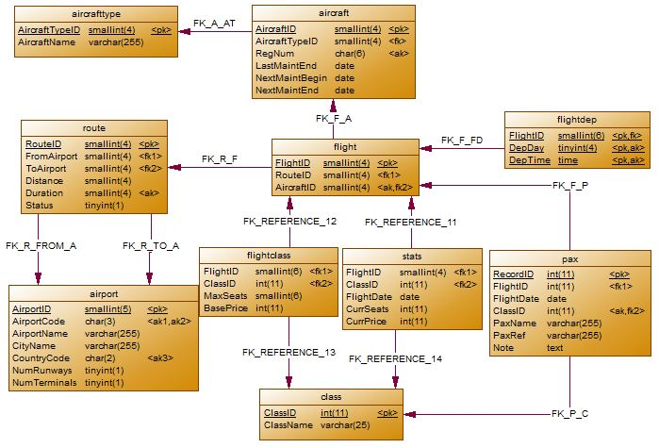

Slika 2. – Fiziki model baze podataka